Visiting An Mheitheal

# A social narrative for visiting the Art for Action Event

## 1.

We are going to visit Printing House Square and An Mheitheal where you will see many different kinds of art.

When I first arrive at Printing House Square, I may notice that the building looks different from the other buildings on Trinity campus.

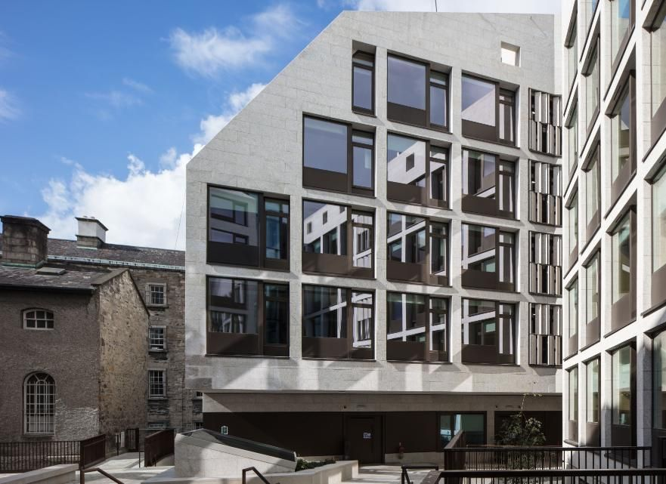

## 2.

I will arrive at the main entrance to the Trinity disAbility Hub in the Printing House Square building. The Trinity disAbility Hub is located here. Sometimes I may need to wait a few seconds until the entrance door opens.

## 3.

Art is a way that I can not only isolate myself—because art is something that I do in a quiet place and focus—it’s also a thing I can use to show people who I am because of what I draw. And what I can show them with my art and what I can do with a pencil and paper is a way of creating a world that I can be happy in without being happy in the world that I am in right now.

## 4.

What art means to me is something that allows me to escape from the world that I’m in now. It allows me to create a place where there’s people I’d love to be, especially as a person who draws mainly characters. It’s a way that I isolate myself from the world because I could just do things on my own. I can draw something on a piece of paper and be happy with it.

I can draw something that I wish I could have, or something that I wish I could be. It feels great to be able to show people what or who I am without even having to use words and just having to use a pencil and paper.